Title (Style "Paper title")
Authors⁽¹⁾ (Style "Authors")
⁽¹⁾ Affiliations (including e-mail address) (Style "Affiliations")
Abstract: (Style "Normal") max. 100 words
Keywords: ("Style "Abstract") max 5 keywords
1 empty line Style "Normal"

Introduction (Style "Heading 1")
Text (Style "Normal")
Page format: A4, margins: 1" top and bottom, 1.25" left and right

Methodology (Style "Heading 1")

List of styles (Style "Heading 2")
Style "Normal" = Arial 9pt, justified
Style "Heading 1" = Arial 10pt bold, 8pt before and after paragraph, numbering
Style "Heading 2" = Arial 9pt bold, 8pt before and after paragraph, second level numbering, indent left 0.2", hanging 0.4"
Style "Figures" = Arial 10pt, italic, centered, 8pt before and after paragraph
Style "Title" = Verdana 12pt bold, left aligned, 16pt before and after paragraph, border bottom
Style "Authors" = Arial 9pt, left aligned, 4pt before and after paragraph
Style "Affiliations" = Arial 9pt italic, left aligned, 4pt before and after paragraph
Style "Abstract" = Arial 9pt, justified, 8pt before and after paragraph
Style "References" = Arial 9pt, justified, 8pt before and after paragraph, numbered between brackets, indent left 0.25", hanging left 0.25"

Examples (Style "Heading 2")
Text (Style "Normal")
Equations (Eq. editor, Style "Figures" right aligned, numbered)
(1)
Figures (Style "Normal" centered), label bellow the figure (Style "Figures")
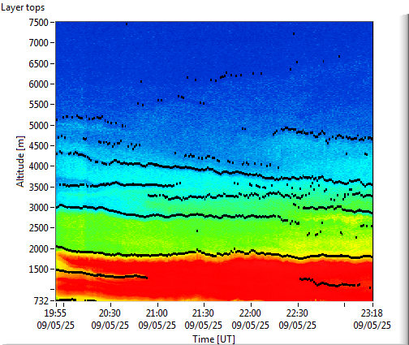
Fig. 1 Range Corrected Signal time series and layer top retrieved from lidar

Tables (Style "Normal" centered) label bellow the table (Style "Figures")
Parameter | Value | Error
Table 1 Parameters and values for scattering coefficients

Results and Discussions (Heading 1)
Similar as before

Conclusions (Heading 1)
Similar as before

References (Style "Heading 1", no numbering)
- Style "References"
- Measures R.M., Laser Remote Sensing. Fundamentals and Applications, Krieger Publishing Company, Malabar, Florida, 1992
- Bösenberg J., et al., EARLINET: A European Aerosol Research Lidar Network, MPI Report, 348, Max-Planck-Institut für Meteorologie, Hamburg, Germany, 2003
- Kovalev, V., and Eichinger, V.,Elastic lidar: Theory, Practice and Analysis Methods, Wiley Interscience Publ., New York, USA, 2004

